Knowing Your State
Area:
Land: Water:
East-West Width:
North-South Length:
River Basins:
Number of Land Regions:
Regions of NC:

Number of Counties:
Highest Point: Lowest Point:
Latitude: Longitude:
Location within the US:
East-West Divider:
Geographical Center of the State:
Capital:
County Capital is located in:
Ocean to the East of NC:
State Bird:
State Flower:
State Moto:
State Tree:
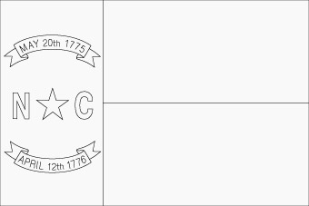
State Flag: Color the state flag!
Significance of the Dates:
May 20th 1775:

April 12th 1776:

