The Korean War (1950 – 1953)

Tensions
- 1910 – 1945: ____________ ruled Korea.
- 1945 (After World War 2): The Allies divided Korea into ____ zones. The Soviet Union occupied the ____________ zone and the ______ ________ occupied the Southern zone.
- North Korea -- _______________ government; Led by Kim Il Sung
- South Korea “the Republic of Korea”-- _______________ government; Led by Syngman Rhee

US Involvement
- The US feared that South Korea would fall to ________________.
- The US then helps build up South Korea’s _____________.
- 1949: US and Soviet Union both remove their troops from North and South Korea.

Fighting Begins
- June 25, 1950: North Korea __________ South Korea.
- The United Nations (UN) became involved and asked for an immediate _______ _______.

Support for South Korea
- June 27, 1950: The UN becomes involved. They label North Korea as an ___________ and offered to support South Korea.
- US sponsored the UN resolution.
- 15 countries gave __________ and ___________ support, but no other country gave as much support as the United States did.
- 90% of the troops sent into Korea were American.

Split Power
- By September the North Koreans had pushed the U.S. and South Korean forces into a _____________.
- September 15, 1950: General MacArthur led a counterattack and recaptured __________ (pronounced “soul”), which is South Korea’s capital.

- The UN and US forces were hit with a counterattack from the North Koreans and eventually had to settle with a defensive line at the ______ ______________.

China’s Involvement
- China aided North Korea in late November.
- Due to China’s involvement, General MacArthur called for a major __________ of the war. His proposal included blockading China’s coast and invading the interior of China.
- Supporters of MacArthur’s plan said it would ___________ the Communist regime in China.
- Opponents argued that blockading China could entice the _________ to become involved.

Truman’s Response
- President Truman __________ MacArthur’s plan
- April 1951: Truman removed MacArthur from his position.
- The war had reached a ___________, a situation in which neither side wins, by the summer of 1951.
- The war became a hot button issue in election of 1952.

Election of 1952
- Dwight D. Eisenhower (Republican) vs. Adlai Stevenson (Democrat)
- Eisenhower promised to end the Korean War yet still resist the _________ _____ ______________.
- Eisenhower won the Electoral College 442-89.
The End of the War
- Eisenhower stayed true to his word to _______ the war.
- Bombing raids increased by the U.S. in ________ ________ in May of 1953.
- July 27th, 1953 an armistice was agreed upon.
- The outcome of the war was the same dividing line that was present before the start of the war, approximately around the ______ ___________.

The Red Scare and McCarthyism

Red Scare:

Note: A lot of people that were communist or considered communists were called “reds.”

- President Truman expands federal gov’t size and power.
- Executive Order 9835 - Barred members of the Communist Party from ___________employment. States started to do this too and many people were forced to take loyalty oaths.
- Senator ____________ _____________: Wisconsin Republican facing defeat in election of 1950; turns to a platform of anti-Communism.
- Comes up with a list of known Communists in the US government.
“I have here a list of 205 names that were made known to the Secretary of State as being members of the Communist Party and who nevertheless are still working and shaping policy in the State Department.” – Joseph McCarthy

McCarthyism:

- McCarthy ______________ many people in Senate hearings and made exaggerated charges.
- Never gave real _______________, but increased his accusations.
- House ______________ Activities Committee (HUAC):
  - Subcommittee of the House of Representatives.
  - Purpose: To root out “subversion” of the American system
  - The Question: “Are you now or have you ever been a member of the _____________ ___________?”
- The McCarran Act:
  - Formal name: The Internal Security Act.
  - Requires communist organizations to _____________ with the Subversive Activities Control Board.
  - Authorizes the arrest of suspect persons during ___________ ______________.
  - Six ____________ _______________ built for this purpose.
- Immigration and Nationality Act:
  - Barred people who were deemed either “subversive” or “homosexual” from becoming ______________ or even visiting the U.S.
  - Power to deport __________________ who were members of the Communist Party, even if they were citizens.
  - In effect until 1973.

Examples of McCarthyism:
- In NYC, citizens must take ________ ___________ to receive a fishing license.
- Hollywood ________________ – screenwriters, actors, musicians, and directors that were denied employment for suspected Communist allegiances.
- Anti-Communist activities under the Federal Bureau of Investigation under J. Edgar Hoover.

Red Scare & McCarthyism Political Cartoons
Directions: Work in your table/group to come up with what you think each political cartoon means in terms of the US, McCarthyism, and the Red Scare.

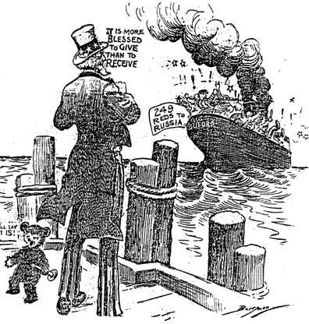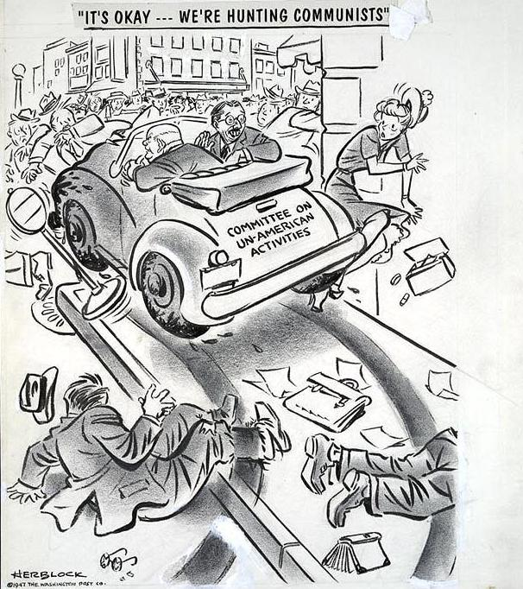

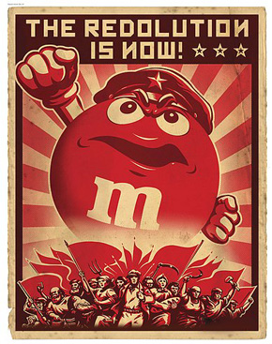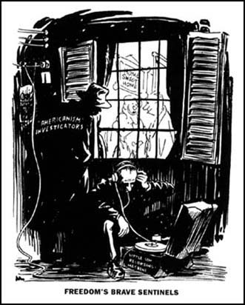

“Reds in Hollywood”

From: http://www.history.com/topics/hollywood-ten

In the years following World War II (1939-45), the United States and Soviet Union engaged in a tense military and political rivalry that became known as the Cold War. Although the U.S. and its communist rival rarely confronted each other directly, they both attempted to extend their influence and promote their systems of government around the world. A number of Americans believed that their nation's security depended on preventing the spread of communism, and this attitude created an atmosphere of fear and suspicion in many parts of the country.

The House Un-American Activities Committee was charged with investigating allegations of communist influence and subversion in the U.S. during the early years of the Cold War. Committee members quickly settled their gaze on the Hollywood film industry, which was seen as a hotbed of communist activity. This reputation originated in the 1930s, when the economic difficulties of the Great Depression increased the appeal of leftist organizations for many struggling actors and studio workers.

With the dawning of the Cold War, anti-communist legislators grew concerned that the movie industry could serve as a source of subversive propaganda. Although popular Hollywood films of the 1930s and 1940s offered little evidence of an overriding Socialist agenda, the investigation proceeded. In October 1947, more than 40 people with connections to the movie industry received subpoenas to appear before HUAC on suspicion of holding communist loyalties or being involved in subversive activities.

Accusing the Accusers

During the investigative hearings, members of HUAC grilled the witnesses about their past and present associations with the Communist Party. Aware that their answers could ruin their reputations and careers, most individuals either sought leniency by cooperating with investigators or cited their Fifth Amendment right against self-incrimination. However, a group of 10 Hollywood screenwriters and directors took a different approach and openly challenged the legitimacy of the committee's investigations.

The 10 individuals who defied HUAC were Alvah Bessie (c. 1904-85), Herbert Biberman (1900-71), Lester Cole (c. 1904-85), Edward Dmytryk (1908-99), Ring Lardner Jr. (1915-2000), John Howard Lawson (1894-1977), Albert Maltz (1908-1985), Samuel Ornitz (1890-1957), Robert Adrian Scott (1912-73) and Dalton Trumbo (1905-76). These men, who became known as the Hollywood Ten, not only refused to cooperate with the investigation but denounced the HUAC anti-communist hearings as an outrageous violation of their civil rights, as the First Amendment to the U.S. Constitution gave them the right to belong to any political organization they chose. Some compared the committee's coercive methods and intimidating tactics to the oppressive measures enacted in Nazi Germany. "I am not on trial here," declared screenwriter Lawson. "This committee is on trial."

Imprisoned and Blacklisted

The Hollywood Ten paid a high price for their actions at the HUAC hearings. In November 1947, they were cited for contempt of Congress. Facing trial on that charge in April 1948, each man was found guilty and sentenced to spend a year in prison and pay a $1,000 fine. After unsuccessfully appealing the verdicts, they began serving their terms in 1950. While in prison, one member of the group, Edward Dmytryk, decided to cooperate with the government. In 1951, he testified at a HUAC hearing and provided the names of more than 20 industry colleagues he claimed were communists.
A more lasting punishment came as a result of the movie industry blacklist. Studio executives did not want their business to be associated with radical politics in the minds of the movie-going public and therefore agreed that they would not employ the Hollywood Ten (with the exception of Dmytryk) or anyone else suspected of being affiliated with the Communist Party. The motion picture industry blacklist grew steadily larger as Congress continued its investigations into the 1950s, and numerous careers were damaged as a result. The blacklist ended in the 1960s.

The Hollywood Ten were controversial figures at the time they launched their protest, and their actions continue to inspire debate decades later. Some tend to view their punishment as justified, since the individuals were admitted communists, while others generally view them as heroic figures who spoke out against the abuses of the Red Scare--and in defense of the U.S. Constitution--when many of their colleagues remained silent.

- What were some words that you did not understand in the passage?

- Why were the Hollywood Ten different than others that appeared in front of HUAC?

- What was each member of the Hollywood Ten charged with?

- How did Edward Dmytryk cooperate with the government?

- Why did studio executives not want to employ the Hollywood Ten?

- Why do some consider the punishment of the Hollywood Ten as justified?

- Why do some consider the Hollywood Ten as heroic figures?

- Looking at questions 6 and 7, which point-of-view do you agree with more? Why?

Cold War – Arms Race (Class SET)
From: http://www.ducksters.com/history/cold_war/arms_race.php

During the Cold War, the United States and the Soviet Union became engaged in a nuclear arms race. They both spent billions and billions of dollars trying to build up huge stockpiles of nuclear weapons. Near the end of the Cold War the Soviet Union was spending around 27% of its total gross national product on the military. This was crippling to their economy and helped to bring an end to the Cold War.
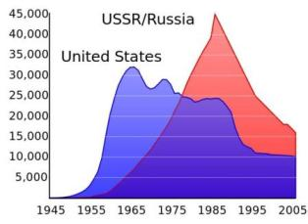
Soviet and United States build up of nuclear weapons
The Nuclear Bomb
The United States was the first to develop the nuclear weapons through the Manhattan Project during World War II. The US ended the war with Japan by dropping nuclear bombs on the cities of Hiroshima and Nagasaki.
Nuclear bombs are extremely powerful weapons that can destroy an entire city and kill tens of thousands of people. The only time nuclear weapons have been used in war was at the end of World War II against Japan. The Cold War was predicated on the fact that neither side wanted to engage in a nuclear war that could destroy much of the civilized world.
Start of the Arms Race
On August 29, 1949 the Soviet Union successfully tested its first atomic bomb. The world was shocked. They did not think the Soviet Union was this far along in their nuclear development. The Arms Race had begun.
In 1952 the United States detonated the first hydrogen bomb. This was an even more powerful version of the nuclear bomb. The Soviets followed up by exploding their first hydrogen bomb in 1953.
ICBMs
In the 1950s both countries worked on developing Intercontinental Ballistic Missiles or ICBMs. These missiles could be launched from long range, as far away as 3,500 miles.
Defense
As both sides continued to develop new and more powerful weapons, the fear of what would happen if war broke out spread throughout the world. Militaries began to work on defenses such as large radar arrays to tell if a missile had been launched. They also worked on defense missiles that could shoot down ICBMs.
At the same time people built bomb shelters and underground bunkers where they could hide in the case of nuclear attack. Deep underground facilities were built for high ranking government officials where they could reside safely.
Mutual Assured Destruction
One of the major factors in the Cold War was termed Mutual Assured Destruction or MAD. This meant that both countries could destroy the other country in the case of attack. It wouldn't matter how successful the first strike was, the other side could still retaliate and destroy the country which first attacked. For this reason, neither side ever used nuclear weapons. The cost was too high.
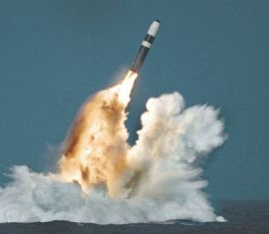
Missile fired from a submarine
Other Countries Involved
During the Cold War, three other nations also developed the nuclear bomb and had their own nuclear weapons. These included Great Britain, France, and the People’s Republic of China.
Détente and Arms Reduction Talks
As the Arms Race heated up, it became very expensive for both countries. In the early 1970s both sides realized that something had to give. The two sides began to talk and take a softer line towards each other. This easing of relations was called détente.
In order to try and slow down the Arms Race, the countries agreed to reduce arms through the SALT I and SALT II agreements. SALT stood for Strategic Arms Limitation Talks.
End of the Arms Race
For the most part, the Arms Race came to an end with the collapse of the Soviet Union at the end of the Cold War in 1991.
Interesting Facts About the Arms Race
- The Manhattan Project was top secret, even Vice President Truman didn't learn about it until he became president. However, Soviet Union leader Joseph Stalin's spies were so good, he knew all about it.
- The US B-52 bomber could fly 6,000 miles and deliver a nuclear bomb.
- It is estimated that by 1961 there were enough nuclear bombs built to destroy the world.
- Today India, Pakistan, North Korea, and Israel also have nuclear capability.

Cold War- Arms Race Quiz
1) What two countries were most involved in the Arms Race during the Cold War?
France and Germany
Cuba and the Netherlands
United States and Soviet Union
Vietnam and China
Japan and the United Kingdom
2) What type of weapon was designed by the Manhattan Project?
Aircraft carrier
Remove drone
Gatling gun
High powered laser
Atomic bomb
3) What country had two atomic bombs dropped on it during World War II?
Germany
Japan
France
Russia
Italy
4) What did MAD stand for in regards to the Arms Race?
Masters Against Defense
Mutual Anti Detonation
Maximum Allowed Devastation
Mutually Assured Destruction
Mass Acceleration Disassembly
5) The easing of relations between the east and west in the Cold War was termed:
Detente
Glasnost
The Warm War
The Melting
Perestroika
6) True or False: The Soviet Union knew all about the Manhattan Project even though it was top secret.
TRUE
FALSE
7) Besides the United States and the Soviet Union, what other countries had nuclear bombs during the Cold War?
Germany, Canada, and India
Japan, Mexico, and Ireland
France, Great Britain, and China
China, Japan, and Vietnam
Australia, Great Britain, and Canada
8) What was the acronym for the arms reduction talks between the United States and the Soviet Union?
CHILE
SALT
PEPPER
BEEF
BAGEL
9) What event effectively ended the Arms Race?
The end of the Vietnam War
The start of the Gulf War
The signing of the SALT agreements
The landing of the first man on the Moon
The collapse of the Soviet Union
10) True or False: Both sides would have suffered great losses in the event of a nuclear war.
TRUE
FALSE

The Space Race Timeline/Flow Chart
November 3, 1957
April 4, 1957

April 12, 1961
National Aeronautics and Space Administration established (NASA).

February 20, 1962
May 5, 1961

July 20, 1969
US Wins Space Race!
June 16-19, 1963

Federal Role in Education
From: https://www2.ed.gov/about/overview/fed/role.html

Overview
Education is primarily a State and local responsibility in the United States. It is States and communities, as well as public and private organizations of all kinds, that establish schools and colleges, develop curricula, and determine requirements for enrollment and graduation. The structure of education finance in America reflects this predominant State and local role. Of an estimated $1.15 trillion being spent nationwide on education at all levels for school year 2011-2012, a substantial majority will come from State, local, and private sources. This is especially true at the elementary and secondary level, where about 87.7 percent of the funds will come from non-Federal sources.
That means the Federal contribution to elementary and secondary education is about 10.8 percent, which includes funds not only from the Department of Education (ED) but also from other Federal agencies, such as the Department of Health and Human Services' Head Start program and the Department of Agriculture's School Lunch program.
Although ED's share of total education funding in the U.S. is relatively small, ED works hard to get a big bang for its taxpayer-provided bucks by targeting its funds where they can do the most good. This targeting reflects the historical development of the Federal role in education as a kind of "emergency response system," a means of filling gaps in State and local support for education when critical national needs arise.
History
The original Department of Education was created in 1867 to collect information on schools and teaching that would help the States establish effective school systems. While the agency's name and location within the Executive Branch have changed over the past 130 years, this early emphasis on getting information on what works in education to teachers and education policymakers continues down to the present day.
The passage of the Second Morrill Act in 1890 gave the then-named Office of Education responsibility for administering support for the original system of land-grant colleges and universities. Vocational education became the next major area of Federal aid to schools, with the 1917 Smith-Hughes Act and the 1946 George-Barden Act focusing on agricultural, industrial, and home economics training for high school students.
World War II led to a significant expansion of Federal support for education. The Lanham Act in 1941 and the Impact Aid laws of 1950 eased the burden on communities affected by the presence of military and other Federal installations by making payments to school districts. And in 1944, the "GI Bill" authorized postsecondary education assistance that would ultimately send nearly 8 million World War II veterans to college.
The Cold War stimulated the first example of comprehensive Federal education legislation, when in 1958 Congress passed the National Defense Education Act (NDEA) in response to the Soviet launch of Sputnik. To help ensure that highly trained individuals would be available to help America compete with the Soviet Union in scientific and technical fields, the NDEA included support for loans to college students, the improvement of science, mathematics, and foreign language instruction in elementary and secondary schools, graduate fellowships, foreign language and area studies, and vocational-technical training.

Bay of Pigs & the Cuban Missile Crisis
Leaders and Type of Government:
US-
Soviet Union-
Cuba-

*Soviet Union promises to provide aid to Cuba

Bay of Pigs (April 1961):
- Castro of Cuba forced many people into exile, or out of Cuba. Many came to live in the United States.
- Cuban exiles trained by the United States’ Central Intelligence Agency (CIA) tried to invade Cuba.
- They landed at the Bay of Pigs on the southern coast of Cuba.
- Invasion made Castro more popular and embarrassed the US.

Cuban Missile Crisis (October 1962):

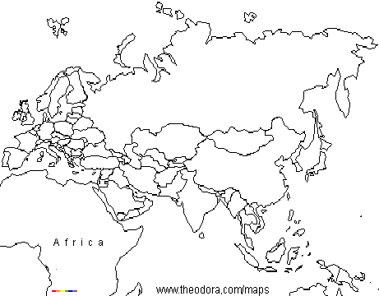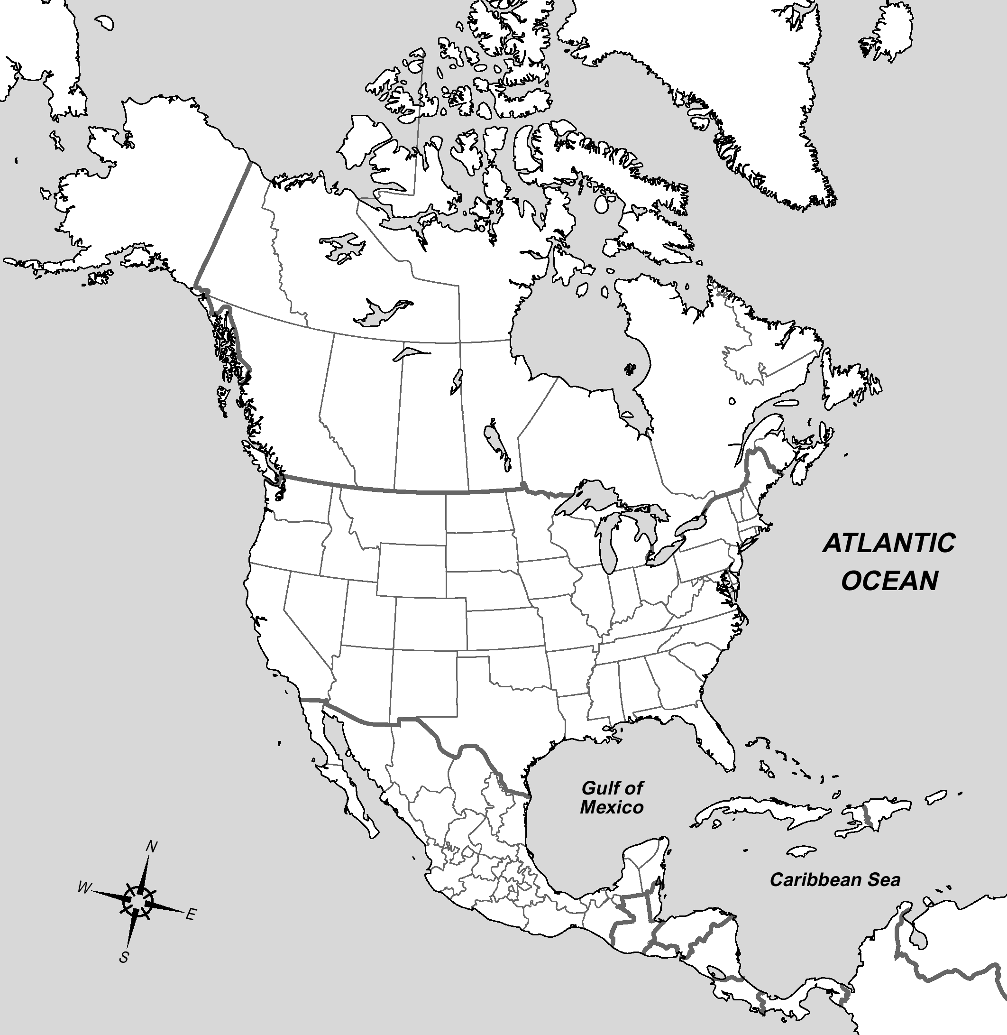
- Kennedy wanted Khrushchev to take missiles out of Cuba.
- The US did a Soviet blockade where they would capture Soviet ships.
- Soviet ships on the way to Cuba turned back at the last second.
- Khrushchev and Kennedy settled the crisis peacefully.
- Soviet Union removed missiles from Cuba.
Cold War Part 1 Review

- Why was the word “cold” used to describe the Cold War?

- What started the Cold War? What ended it?

- Who was involved (countries), and what types of government did they have?

- Who used the term “iron curtain” in a popular speech? What does the term “iron curtain” mean?

- What was the Truman Doctrine?

- What was the Marshall Plan? Why was it considered a success?

- How many zones was Germany divided into originally after World War 2? Which zones were combined together for form West Germany?

- What was the Berlin Airlift?

- What does NATO stand for? What are the similarities and differences between NATO and the Warsaw Pact?

- What type of government did/does North Korea have? South Korea?

- Who won the Korean War/Conflict?

- What is the 38th parallel?

- What was the red scare?

- Who were the Hollywood 10?

- Describe the Cuban Missile Crisis.

- What are you still confused on in what has been taught so far?

