Sputnik
- On October 4, 1957, the Soviets launched Sputnik, __________________________
____________________________________________________________________________
- Sputnik weighed 184 pounds and was 23 inches in diameter. It sent out a "beep-beep" ________________________ through its four antennas that scientists and ham radio operators throughout the _________________________.
- Sputnik’s signal continued until the transmitter ____________________ ran out on _______________________________.
- Sputnik remained in orbit until _________________________, but burned up when re-entering earth’s atmosphere
- Following Sputnik’s _________________________, the Soviets launched ________ of Sputnik’s.
Sputnik II
- Sputnik II, launched on November 3, 1957, ____________________ named Laika on board. Laika was the __________________________________________________. She survived for only a few hours instead of the planned ten days because of overheating and stress.
The United State’s Reaction to Sputnik
- President ____________________________felt that Sputnik was insignificant. However, many people disagreed and felt that it was a step closer to a ________________________________________________________.
- At this point, the Soviets were basically winning the space race. The president was able to recognize this, and __________________________________ to form NASA, the _________________________________________________________. Congress passed the bill.
- Senator Lyndon Johnson played an important role in the ____________________
________________________________. He later became president of the United States after John F. Kennedy was assassinated.
The First Man To Orbit The Earth
- On April 12, 1961, ____________________________________ was launched into space aboard the Soviet vessel Vostok I, making him ________________________
________________________________________________.
- The ship made a single orbit around the earth, and the flight only lasted about 1 hour 28 minutes.
- This was another great victory for the Soviet Union and a big step towards _______________________________________________________.
The First American In Space
- On May 5, 1961, ________________________ became the first American in space.
- Launched on top of a Redstone missile, he made a short, suborbital flight in a _______________________________.
- Later, on February 20, 1962, John Glenn became the first American to orbit the earth.
Soviet Union Advancements
- While the United States struggled to surpass Russia in _____________________ ______________________________, the Russians were continuing to achieve more and more.
- Soviet cosmonaut Valentina Tereshkova was _________________________________. She rode aboard Vostok 5 on June 16-19, 1963.
U.S. Lands On The Moon
- On July 20, 1969, astronauts _______________________________________________ became the first men to reach the moon.
- Meanwhile Michael Collins orbited the moon in the Command Module.
- The mission was called the ________________________________________________.
The United States Wins the Space Race
- With the landing of Neil Armstrong and Buzz Aldrin on the moon, the United States officially _________________________________________________________.
- The Cold War continued after the Space Race until the break up of the Soviet Union, which would not occur until _____________________________________.
After The Space Race
- Because the U.S. had demonstrated it’s superiority over Russia, there wasn’t such a rush to ____________________________________________________________.
- America lost interest in the moon, finishing the missions there with Apollo 17, and shifted it’s concentration to building the ________________________.
- The Soviets never did send a man to the moon. They did, however, send a number of _________________________________________________________________.
- These robots were called Lunokhod, and they sent back all video footage and photographs they took of the moon.
- After many years of desperate research, testing, hard work, and sacrifice, the Russians had __________________________________________________________.
The Space Race - Activity
“We have vowed that we shall see space filled not with weapons of mass destruction, but with instruments of knowledge and understanding" -President Kennedy, Rice University, Houston, Texas, September 12, 1962
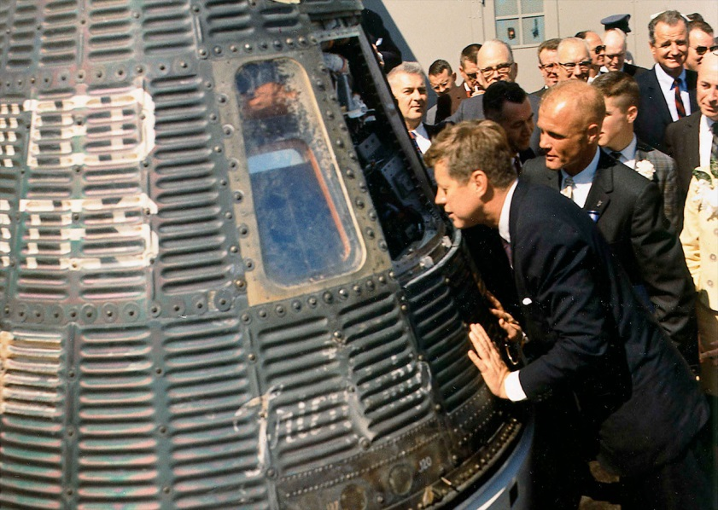
President Kennedy was eager for the United States to lead the way in exploring space. The Soviet Union was ahead of the United States, having launched the first satellite Sputnik in 1957 and the first cosmonaut Yuri Gagarin to orbit around the earth in 1961. President Kennedy said, “No nation which expects to be the leader of other nations can expect to stay behind in this race for space.” In 1961 Kennedy asked Congress to approve more than twenty two billion dollars for Project Apollo, which had the goal of landing an American man on the moon before the end of the decade.

Directions: Read the three primary sources (Class Set) and answer the questions that follow.

Description of Primary Sources
- On April 12, 1961 cosmonaut Yuri A. Gagarin from the Soviet Union orbited around the earth in 108 minutes. The same day President Kennedy wrote a telegram to Premier Nikita Khrushchev congratulating the Soviets on the first successful manned flight.

- A few days later President Kennedy wrote a memo on April 20, 1961 to Vice President Lyndon B. Johnson, who was the chairman of the Space Council.

Questions
- In the telegram to Premier Nikita Khrushchev, how does President Kennedy say he would like the United States and the Soviet Union to work on exploring outer space?
- In the memo to Vice President Lyndon Johnson, what is President Kennedy's main objective?
- What is the main difference between what President Kennedy says in the telegram and what he says in the memo in terms of how the Americans and the Soviets should explore outer space?
- Why do you think President Kennedy appears to be giving two conflicting statements?

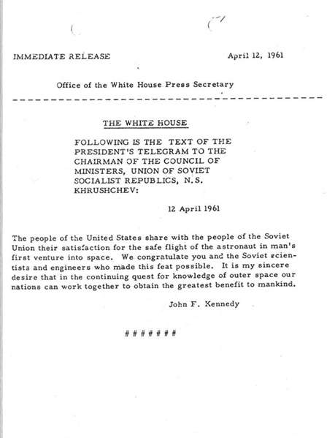
Document A
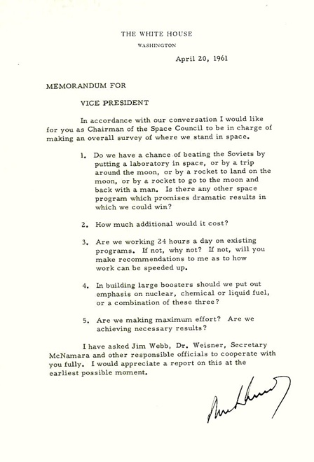
Document B

