Locating the Site
Map 1: Land occupied by Southeastern Tribes, 1820s.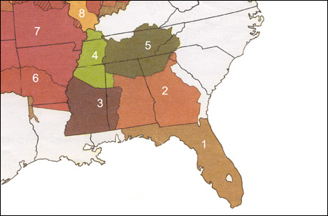
(Adapted from Sam Bowers Hilliard, "Indian Land Cessions" [detail], Map Supplement 16, Annals of the Association of American Geographers, vol. 62, no. 2 [June 1972].)
Questions for Map 1
1. Even after ceding, or yielding, millions of acres of their territory through a succession of treaties with the British and then the U.S. government, the Cherokees in the 1820s still occupied parts of the homelands they had lived in for hundreds of years. What modern states are included within the boundaries of the Cherokee Nation? How large is the territory compared with the modern states?
2. What other tribes lived near the Cherokees? Whites often referred to the Cherokee, Chickasaw, Choctaw, Creek, and Seminole as the "Five Civilized Tribes." What do you think whites meant by "civilized?"
* The map on this screen has a resolution of 72 dots per inch (dpi), and therefore will print poorly. You can obtain a larger version of Map 1, but be aware that the file may take as much as 50 seconds to load with a 28.8K modem.

Key:
1. Seminole
2. Creek
3. Choctaw
4. Chickasaw
5. Cherokee
6. Quapaw
7. Osage
8. Illinois Confederation

Map 2: Cherokee Removal Routes. 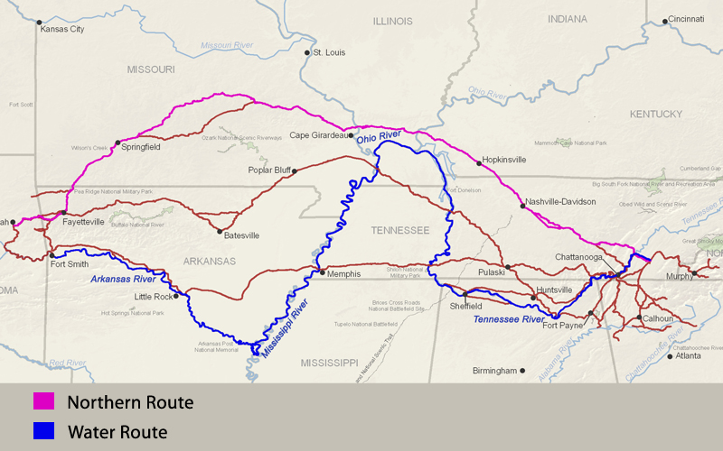
(National Park Service)
This map shows the routes followed west by the Cherokee Nation to reach "Indian Territory," now the state of Oklahoma, in the 1830s. The pink trail is the northern route. It was a land route and the largest group of Cherokees followed this part of the trail. The blue trail is the water route. The red trails show the other routes on the trail.
Questions for Map 2
1. How many different routes are shown? Why do you think there might have been so many?
2. Find the water route. What rivers does it follow? What advantages to you think it might have over an overland route? What difficulties might it present?
3. Locate the northern route. How does it compare with the other main routes? What major rivers did it cross? What advantages and what disadvantages might the northern route have?
4. The largest group of Cherokees left Tennessee in the late fall of 1838, followed the northern route, and arrived in Indian Territory in March. What problems do you think they might have encountered on the journey?
Reading 1: The Cherokee Nation in the 1820s
Cherokee culture thrived for thousands of years in the southeastern United States before European contact. When the Europeans settlers arrived, the Indians they encountered, including the Cherokee, assisted them with food and supplies. The Cherokees taught the early settlers how to hunt, fish, and farm in their new environment. They introduced them to crops such as corn, squash, and potatoes; and taught them how to use herbal medicines for illnesses.
By the 1820s, many Cherokees had adopted some of the cultural patterns of the white settlers as well. The settlers introduced new crops and farming techniques. Some Cherokee farms grew into small plantations, worked by African slaves. Cherokees built gristmills, sawmills, and blacksmith shops. They encouraged missionaries to set up schools to educate their children in the English language. They used a syllabary (characters representing syllables) developed by Sequoyah (a Cherokee) to encourage literacy as well. In the midst of the many changes that followed contact with the Europeans, the Cherokee worked to retain their cultural identity operating "on a basis of harmony, consensus, and community with a distaste for hierarchy and individual power."¹
In 1822, the treasurer of the American Board of Commissioners for Foreign Missions reported on some of the changes that had been made:
It used to be said, a few years since, with the greatest of confidence, and is sometimes repeated even now, that "Indians can never acquire the habit of labour." Facts abundantly disprove this opinion. Some Indians not only provide an abundant supply of food for their families, by the labour of their own hands, but have a surplus of several hundred bushels of corn, with which they procure clothing, furniture, and foreign articles of luxury.²
Two leaders played central roles in the destiny of the Cherokee. Both had fought along side Andrew Jackson in a war against a faction of the Creek Nation which became known as the Creek War (1813-1814). Both had used what they learned from the whites to become slave holders and rich men. Both were descended from Anglo-Americans who moved into Indian territory to trade and ended up marrying Indian women and having families. Both were fiercely committed to the welfare of the Cherokee people.
Major Ridge³ and John Ross shared a vision of a strong Cherokee Nation that could maintain its separate culture and still coexist with its white neighbors. In 1825, they worked together to create a new national capitol for their tribe, at New Echota in Georgia. In 1827, they proposed a written constitution that would put the tribe on an equal footing with the whites in terms of self government. The constitution, which was adopted by the Cherokee National Council, was modeled on that of the United States. Both men were powerful speakers and well able to articulate their opposition to the constant pressure from settlers and the federal government to relocate to the west. Ridge had first made a name for himself opposing a Cherokee proposal for removal in 1807. In 1824 John Ross, on a delegation to Washington, D.C. wrote:
We appeal to the magnanimity of the American Congress for justice, and the protection of the rights, liberties, and lives, of the Cherokee people. We claim it from the United States, by the strongest obligations, which imposes it upon them by treaties; and we expect it from them under that memorable declaration, "that all men are created equal."⁴
Not all tribal elders or tribal members approved of the ways in which many in the tribe had adopted white cultural practices and they sought refuge from white interference by moving into what is now northwestern Arkansas. In the 1820s, the numbers of Cherokees moving to Arkansas territory increased. Others spoke out on the dangers of Cherokee participation in Christian churches, and schools, and predicted an end to traditional practices. They believed that these accommodations to white culture would weaken the tribe's hold on the land.
Even as Major Ridge and John Ross were planning for the future of New Echota and an educated, well-governed tribe, the state of Georgia increased its pressure on the federal government to release Cherokee lands for white settlement. Some settlers did not wait for approval. They simply moved in and began surveying and claiming territory for themselves. A popular song in Georgia at the time included this refrain:
All I ask in this creation
Is a pretty little wife and a big plantation
Way up yonder in the Cherokee Nation.⁵
Questions for Reading 1
1. In what ways did the Cherokees adopt aspects of white culture? What did they do to protect Cherokee culture?
2. What did Major Ridge and John Ross have in common? What were their plans for the Cherokee Nation? Do you think these changes would protect the tribe's land? Why or why not?
3. Why did some Cherokees oppose these changes? If you were a Cherokee, which group do you think you would agree with? Why?
4. Why do you think John Ross, who was only one-eighth Cherokee and who was raised and educated in the white community, might have identified so strongly with his Indian heritage?
5. Read John Ross's letter to Congress carefully. What is its tone and what points does he make? Even though he was a slave holder, he appeals to the words of the Declaration of Independence. Do you think this strengthens his argument? Do you think it is an effective appeal? Why or why not?

Reading 2: "You cannot remain where you now are...."
The Cherokees might have been able to hold out against renegade settlers for a long time. But two circumstances combined to severely limit the possibility of staying put. In 1828 Andrew Jackson became president of the United States. In 1830--the same year the Indian Removal Act was passed--gold was found on Cherokee lands. There was no holding back the tide of Georgians, Carolinians, Virginians, and Alabamians seeking instant wealth. Georgia held lotteries to give Cherokee land and gold rights to whites. The state had already declared all laws of the Cherokee Nation null and void after June 1, 1830, and also prohibited Cherokees from conducting tribal business, contracting, testifying against whites in court, or mining for gold. Cherokee leaders successfully challenged Georgia in the U.S. Supreme Count, but President Jackson refused to enforce the Court's decision.
Most Cherokees wanted to stay on their land. Chief Womankiller, an old man, summed up their views:
My sun of existence is now fast approaching to its setting, and my aged bones will soon be laid underground, and I wish them laid in the bosom of this earth we have received from our fathers who had it from the Great Being above.¹
Yet some Cherokees felt that it was futile to fight any longer. By 1832, Major Ridge, his son John, and nephews Elias Boudinot and Stand Watie had concluded that incursions on Cherokee lands had become so severe, and abandonment by the federal government so certain, that moving was the only way to survive as a nation. A new treaty accepting removal would at least compensate the Cherokees for their land before they lost everything. These men organized themselves into a Treaty Party within the Cherokee community. They presented a resolution to discuss such a treaty to the Cherokee National Council in October 1832. It was defeated. John Ross, now Principal Chief, was the voice of the majority opposing any further cessions of land. The two men who had worked so closely together were now bitterly divided.
The U.S. government submitted a new treaty to the Cherokee National Council in 1835. President Jackson sent a letter outlining the treaty terms and urging its approval:
My Friends: I have long viewed your condition with great interest. For many years I have been acquainted with your people, and under all variety of circumstances in peace and war. You are now placed in the midst of a white population. Your peculiar customs, which regulated your intercourse with one another, have been abrogated by the great political community among which you live; and you are now subject to the same laws which govern the other citizens of Georgia and Alabama.
I have no motive, my friends, to deceive you. I am sincerely desirous to promote your welfare. Listen to me, therefore, while I tell you that you cannot remain where you now are. Circumstances that cannot be controlled, and which are beyond the reach of human laws, render it impossible that you can flourish in the midst of a civilized community. You have but one remedy within your reach. And that is, to remove to the West and join your countrymen, who are already established there. And the sooner you do this the sooner you will commence your career of improvement and prosperity.²
John Ross persuaded the council not to approve the treaty. He continued to negotiate with the federal government, trying to strike a better bargain for the Cherokee people. Each side--the Treaty Party and Ross's supporters--accused the other of working for personal financial gain. Ross, however, had clearly won the passionate support of the majority of the Cherokee nation, and Cherokee resistance to removal continued.
In December 1835, the U.S. resubmitted the treaty to a meeting of 300 to 500 Cherokees at New Echota. Older now, Major Ridge spoke of his reasons for supporting the treaty:
I am one of the native sons of these wild woods. I have hunted the deer and turkey here, more than fifty years. I have fought your battles, have defended your truth and honesty, and fair trading. The Georgians have shown a grasping spirit lately; they have extended their laws, to which we are unaccustomed, which harass our braves and make the children suffer and cry. I know the Indians have an older title than theirs. We obtained the land from the living God above. They got their title from the British. Yet they are strong and we are weak. We are few, they are many. We cannot remain here in safety and comfort. I know we love the graves of our fathers. We can never forget these homes, but an unbending, iron necessity tells us we must leave them. I would willingly die to preserve them, but any forcible effort to keep them will cost us our lands, our lives and the lives of our children. There is but one path of safety, one road to future existence as a Nation. That path is open before you. Make a treaty of cession. Give up these lands and go over beyond the great Father of Waters.³
Twenty men, none of them elected officials of the tribe, signed the treaty, ceding all Cherokee territory east of the Mississippi to the U.S. in exchange for $5 million and new homelands in Indian Territory. Major Ridge is reported to have said that he was signing his own death warrant.
The Treaty of New Echota was widely protested by Cherokees and by whites. The tribal members who opposed relocation considered Major Ridge and the others who signed the treaty traitors. After an intense debate, the U.S. Senate approved the Treaty of New Echota on May 17, 1836, by a margin of one vote. It was signed into law on May 23. As John Ross worked to negotiate a better treaty, the Cherokees tried to sustain some sort of normal life--even as white settlers carved up their lands and drove them from their homes. Removal had become inevitable. It was simply a matter now of how it would be accomplished.

Questions for Reading 2
1. Based on the quotations from Chief Womankiller and Major Ridge, how did the Cherokee feel about their land? Why did the majority of the Cherokees oppose the treaty?
2. In Andrew Jackson's letter of 1835 to the Cherokee council, he says that the tribal fathers were well-known to him "in peace and in war." What war is he referring to? What was his relationship to the Cherokees during that war? What is the tone of his letter? If needed, refer to Reading 1.
3. What points does Major Ridge make in his speech to the tribal council? Why was Ridge in favor of the treaty? Do you think he makes a persuasive case for approval?
4. Why was the Treaty of New Echota so widely criticized? The U.S. Constitution required that the treaty be ratified by the U.S. Senate. Under the Cherokee Constitution, treaties had to be approved by the Cherokee National Council. Did this occur with the treaty of 1835? Do you think the U.S. government had the right to enforce this treaty?

Reading 3: "Every Cherokee man, woman or child must be in motion..."
For two years after the Treaty of New Echota, John Ross and the Cherokees continued to seek concessions from the federal government, which remained disorganized in its plans for removal. Only the eager settlers with their eyes on the Cherokee lands moved with determination. At the end of December 1837, the government warned Cherokee that the clause in the Treaty of New Echota requiring that they should "remove to their new homes within two years from the ratification of the treaty" would be enforced.¹ In May, President Van Buren sent Gen. Winfield Scott to get the job done. On May 10, 1838, General Scott issued the following proclamation:
Cherokees! The President of the United States has sent me, with a powerful army, to cause you, in obedience to the Treaty of 1835, to join that part of your people who are already established in prosperity, on the other side of the Mississippi. . . . The full moon of May is already on the wane, and before another shall have passed away, every Cherokee man, woman and child . . . must be in motion to join their brethren in the far West.²
Federal troops and state militias began to move the Cherokees into stockades. In spite of warnings to troops to treat them kindly, the roundup proved harrowing. A missionary described what he found at one of the collection camps in June:
The Cherokees are nearly all prisoners. They have been dragged from their houses, and encamped at the forts and military posts, all over the nation. In Georgia, especially, multitudes were allowed no time to take any thing with them except the clothes they had on. Well-furnished houses were left prey to plunderers, who, like hungry wolves, follow in the trail of the captors. These wretches rifle the houses and strip the helpless, unoffending owners of all they have on earth.³
Three groups left in the summer, traveling from present-day Chattanooga by rail, boat, and wagon, primarily on the water route, but as many as 15,000 people still awaited removal. Sanitation was deplorable. Food, medicine, clothing, even coffins for the dead, were in short supply. Water was scarce and often contaminated. Diseases raged through the camps. Many died.
Those travelling over land were prevented from leaving in August due to a summer drought. The first detachments set forth only to find no water in the springs and they returned back to their camps. The remaining Cherokees asked to postpone removal until the fall. The delay was granted, provided they remain in the camps until travel resumed. The Army also granted John Ross's request that the Cherokees manage their own removal. The government provided wagons, horses, and oxen; Ross made arrangements for food and other necessities. In October and November, 12 detachments of 1,000 men, women, children, including more than 100 slaves, set off on an 800 mile-journey overland to the west. Five thousand horses, and 654 wagons, each drawn by 6 horses or mules, went along. Each group was led by a respected Cherokee leader and accompanied by a doctor, and sometimes a missionary. Those riding in the wagons were usually only the sick, the aged, children, and nursing mothers with infants.
The northern route, chosen because of dependable ferries over the Ohio and Mississippi Rivers and a well-travelled road between the two rivers, turned out to be the more difficult. Heavy autumn rains and hundreds of wagons on the muddy route made roads nearly impassable; little grazing and game could be found to supplement meager rations. Two-thirds of the Cherokees were trapped between the ice-bound Ohio and Mississippi rivers during January. A traveler from Maine happened upon one of the caravans in Kentucky:
We found the road literally filled with the procession for about three miles in length. The sick and feeble were carried in waggons . . . a great many ride horseback and multitudes go on foot—even aged females, apparently nearly ready to drop into the grave, were traveling with heavy burdens attached to the back—on the sometimes frozen ground, and sometimes muddy streets, with no covering for the feet except what nature had given them.⁴
A Cherokee survivor later recalled:
Long time we travel on way to new land. People feel bad when they leave Old Nation. Women cry and made sad wails. Children cry and many men cry, and all look sad like when friends die, but they say nothing and just put heads down and keep on go towards West. Many days pass and people die very much.⁵
In 1972, Robert K. Thomas, a professor of anthropology from the University of Chicago and an elder in the Cherokee tribe, told the following story to a few friends:
Let me tell you this. My grandmother was a little girl in Georgia when the soldiers came to her house to take her family away. . . . The soldiers were pushing her family away from their land as fast as they could. She ran back into the house before a soldier could catch her and grabbed her [pet] goose and hid it in her apron. Her parents knew she had the goose and let her keep it. When she had bread, she would dip a little in water and slip it to the goose in her apron.
Well, they walked a long time, you know. A long time. Some of my relatives didn't make it. It was a bad winter and it got really cold in Illinois. But my grandmother kept her goose alive.
One day they walked down a deep icy gulch and my grandmother could see down below her a long white road. No one wanted to go over the road, but the soldiers made them go, so they headed across. When my grandmother and her parents were in the middle of the road, a great black snake started hissing down the river, roaring toward the Cherokees. The road rose up in front of her in a thunder and came down again, and when it came down all of the people in front of her were gone, including her parents.
My grandmother said she didn't remember getting to camp that night, but she was with her aunt and uncle. Out on the white road she had been so terrified, she squeezed her goose hard and suffocated it in her apron, but her aunt and uncle let her keep it until she fell asleep. During the night they took it out of her apron.⁶
On March 24, 1839, the last detachments arrived in the west. Some of them had left their homeland on September 20, 1838. No one knows exactly how many died during the journey. Missionary doctor Elizur Butler, who accompanied one of the detachments, estimated that nearly one fifth of the Cherokee population died. The trip was especially hard on infants, children, and the elderly. An unknown number of slaves also died on the Trail of Tears. The U.S. government never paid the $5 million promised to the Cherokees in the Treaty of New Echota.
Questions for Reading 3
1. What is the tone of General Scott's message to the Cherokees? Would you have tried to resist the removals after hearing Scott's message?
2. What happened to the Cherokee between May and October of 1838? What was life like for the Cherokee during that period?
3. With little time to plan and prepare, 17,000 Cherokee with their possessions, horses, and wagons moved from their homelands to Oklahoma. This type of mass migration was unprecented in the early 19th century. What sort of arrangements would be needed to prepare for and carry out such a mass movement of people? If you were given a short amount of time to leave your home and move to an unknown place, how would you feel? What would you take with you?
4. What do you think would have been the worst part of the entire removal process?
5. Do you think Robert Thomas's story about his grandmother is based on a real event? What do the students think the white road represented? In oral traditions, the speaker often "telescopes" historical time, collapsing one or more generations. Do you think the woman in Thomas's account was really his grandmother? Is that important? Do you think the story was intended as factual history? If not, what was it intended to record?

The Ridge House.
The Ridge House is located in Rome, Georgia, near New Echota, the Cherokee national capital. The two windows to the left of the front door were part of the earliest part of this house, a log cabin of two rooms separated by an open breezeway. By the time of the relocation, Major Ridge (Cherokee leader, a member of the tribal council, and a lawmaker.) had enlarged the cabin into a fine house, with eight rooms, 30 glass windows, four brick fireplaces, and paneling in the parlor. The two one-story wings were added in the 20th century.

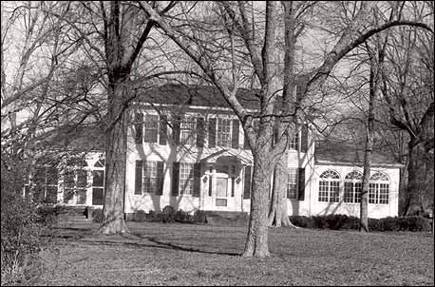
(National Park Service)
Questions for Photo 1
1. This house was part of a 223-acre plantation farmed by about 30 slaves. The property also included a ferry, a store, and a toll road, all sources of considerable wealth. In what ways does the house demonstrate that Major Ridge was a rich man? Do you think that was the impression he intended to create?
2. Can you see any features that might indicate that this house was built by a Cherokee? In what ways do you think the design of the house reflects Ridge's attitudes towards accommodation to white society?
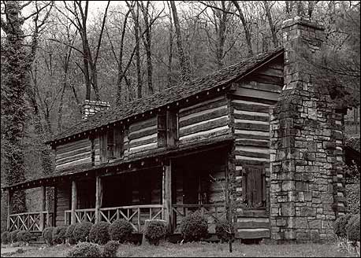
Photo 2: John Ross House.
This log house is located in Rossville, Georgia, on the Georgia-Tennessee border near Chattanooga. It consists of two rooms on each floor separated by a central breezeway, now enclosed, and was built in the 1790s by John Ross's grandfather. (John Ross was the son of a Cherokee mother and a Scottish father.)Ross lived here with his grandparents as a boy and the house later served as a headquarters for the enterprises that made him a rich man. The property also included a large farm, worked by slaves. Ross also owned a supply depot and warehouse at Ross's Landing (now in Chattanooga).

(National Park Service)
Questions for Photo 2
1. Before it was enlarged, Major Ridge's house probably looked much like this house. Does the Ross house look like the home of a rich man?
2. In 1826, Ross moved to a large plantation near Rome, Georgia, only about a mile from Major Ridge. Why do you suppose he moved there?
3. In 1832, Ross returned from a trip to Washington to find that his plantation had been taken over by Georgia whites who had won it in the lottery for Cherokee land. He moved back into this house, where he stayed until removal. How do you think he would have felt returning to his old home under these circumstances?
Illustration 1: Artist's Conception of a Cherokee Homestead, early 1830s.
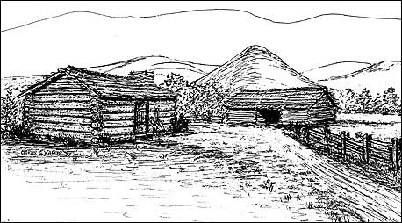
(Courtesy of Charles O. Walker, artist)
This illustration shows the homestead of Lying Fish, located in a relatively remote valley in northern Georgia. In the early 1830s, Lying Fish's homestead included a 16 by 14 foot log house with a wooden chimney, another house of the same size, a corn crib, a stable, 19 acres of cleared bottom land, of which six were on the creek, 30 peach trees and 3 apple trees.
Questions for Illustration 1
1. Most Cherokees lived on small farms like this. Compare the house shown here with the Ridge and Ross houses. How do they differ? How are they alike?
2. How does the farm compare with what you know about the farms of Major Ridge and John Ross?
3. Cherokees living on farms like this rarely had white ancestors and were unlikely to speak English. How do you think that might affect their attitudes towards adopting some of the white cultural and agricultural practices? How might it affect their attitude towards the Treaty of New Echota?

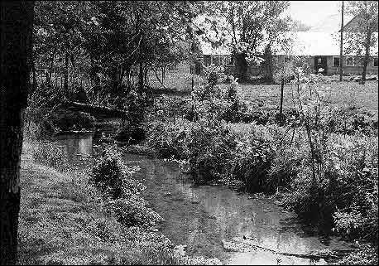
Photo 3: Rattlesnake Springs.
Rattlesnake Springs was one of the stockade camps where Cherokees were initially collected after being forced off of their land. It is located in the far southeastern corner of Tennessee, near the North Carolina border. The farm buildings shown in this recent view would not have been there in 1838.

(National Park Service, James F. Corn, photographer)
Questions for Photo 3
1. There were 600 Cherokees camped at Rattlesnake Springs in July 1838, waiting to leave for the west. Why do you think the U.S. Army might have located a camp here?
2. There were more than 4,800 Cherokees waiting at camps in this general area before relocation. How difficult do you think it would have been to provide food and supplies for such a large group in a sparsely populated rural area?
3. The final Council of the eastern Cherokees was held at Rattlesnake Springs. Lamentations were pronounced and the Council determined to continue their old constitution and laws in the new land. Why do you think it was important to the Cherokees to do these things before leaving for the west?

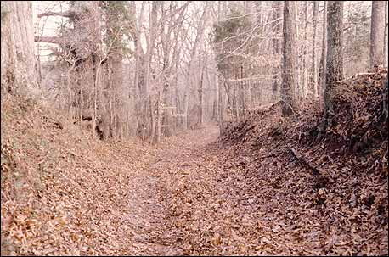
Photo 4: Trail Remnant on the Land Route.
(Tennessee Department of Environment and Conservation, Benjamin Nance, photographer)
Questions for Photo 4
1. This photo shows a segment of road believed to have been used during the Cherokee removal of 1838. How do you think this road would have looked after hundreds of wagons, and thousands of people, horses, and oxen had passed over it?
2. What can you learn from looking at this roadway that you did not learn from the readings? What do you think you could learn by actually being on the road?
3. This trail segment has survived because it is used as a private farm road. Do you think it should be preserved unchanged? Why or why not? Do you think it would be a good idea to have a historic marker identifying it as part of the Trail of Tears? What advantages and disadvantages might that have?

Putting It All Together
Station 4: Choose 1
Choose 1

By reading "The Trail of Tears and the Forced Relocation of the Cherokee Nation" students will appreciate the pressures working to force the Cherokees off their homelands and the painful divisions those pressures created within the tribe itself. The following activities will help them apply what they have learned.
Activity 1: Accommodate or resist?
The Cherokees were divided on the issue of adopting aspects of white culture or trying to maintain their traditions unchanged. Ask students to review the readings, consider the following questions, and then hold a classroom discussion based on their answers. What were the effects of the choices made by the groups of Cherokees discussed in the readings? Did accommodation help the Cherokee Nation keep its land? Did it benefit individual Cherokees? How do you think adopting elements of white culture impacted the traditional practices of the Cherokees?
Activity 2: Ridge vs. Ross
Bitter hostility between the supporters of John Ross and those of the Treaty Party continued after the Cherokees established themselves in Indian Territory. Because they had ceded tribal lands without the consent of the tribe, Major Ridge, John Ridge, and Elias Boudinot were murdered in 1839. In the 1860s, Stand Watie, the brother of Elias Boudinot who had barely escaped assassination, led Confederate troops against John Ross's supporters in the Civil War. Historians of the Cherokee removal are equally divided in their appraisals of the two men. Some see Major Ridge and his allies as realists whose treaty was probably the best possible solution in an impossible situation. For others, John Ross was a hero, "a towering figure of resistance to U.S. efforts to uproot and remove the entire Cherokee Nation."¹ Divide students into two groups. Have one represent John Ross and the other Major Ridge and his allies. Have each group select a spokesman to make a presentation defending the position of the person they represent. Ask the class to pretend they are members of the Cherokee National Council. Ask them to vote on whether they should or should not approve the Treaty of New Echota.
Activity 3: Historical Evidence
This lesson on the Trail of Tears uses a wide variety of historical evidence. Ask the students to review the readings and visual materials and make a list of the kinds of evidence presented in the lesson (historical quotations, oral histories, illustrations, photographs, etc.) Have students work in groups and have each group select four pieces of evidence. For each one, ask them to list 1) what kind of evidence it is (speech, letter, map, photograph, etc.), 2) when it was created, 3) what facts it contains, 3) what other kinds of information it provides, 4) why it was created, and 5) what it adds to their understanding of the Cherokee experience and the Trail of Tears.
Activity 4: American Indian Treaties in the Community
Ask students to look at a map of their region that identifies the American Indian tribes that were present at the time of white settlement. Have them look up any treaty agreements between the tribes living in their region and the U.S. government. What provisions did they contain? Did the U.S. adhere to them? Are these tribes still present in the region? Have they disappeared? If they are no longer in the area, where are they now located? If some tribes are present, are there still treaty issues being debated or negotiated today? Students should present their findings to class for discussion on how their research of other tribe's experiences compare with that of the Cherokee Nation.
Activity 5: American Indian Relocation
The Cherokee were only one of the many tribes forced to relocate from their homes and travel to a strange land. Divide the class into four groups and have each group research the history of one of the following tribes now living in Oklahoma, making sure that each tribe is covered: Choctaw, Chickasaw, Creek, and Seminole. Ask each group to compare the culture of the tribe it researched, and its forced removal experiences, to that of the Cherokee. Have each group appoint a spokesperson to report its findings to class, including a brief update on its tribal nation in the 21st century. This activity may be expanded by having the class work together to create an exhibit for their school or local library telling the story of the five tribes' journeys from their traditional homelands to Indian Territory.

