Cuba & the Cold War
Historical Introduction:
In the years after the Second World War, many small nations throughout the world (especially newly independent nations throughout Asia, Africa, and Latin America) were caught up in the Cold War struggle between the two global superpowers: The United States and the Soviet Union (U.S.S.R). The United States sought to spread its economic system, capitalism, to these smaller nations, while the Soviet Union wanted to extend its system, communism, throughout the world. There was often great conflict within these smaller nations over the question of whether they should be friendly to the United States and its capitalist system or to the Soviet Union and its communist system.
On New Year’s Day, 1959, Cuban revolutionary Fidel Castro overthrew the dictatorship of Fulgencio Batista. Batista had been very friendly with the United States and the Americans had supported his regime until just before he was forced from power. The United States supported the Batista regime mainly because it was anti-communist and protected the numerous American business interests (companies) in Cuba that made very good money producing and exporting Cuban sugar and tobacco, among other products, to the United States. Due to Castro’s revolution, however, Batista was forced to flee Cuba. The American government was suspicious of Castro’s new government and his left-wing politics, as well as his harsh treatment of the former Batista government. Also, he seriously angered the United States when he began to nationalize some of the American corporations located in Cuba.

Bay of Pigs
America’s growing fury with Castro, and the Cuban Revolution in turn, pushed the Cubans closer to America’s great enemy, the Soviet Union. Castro and Chairman Khrushchev became friendly, and as a result, Soviet-style communism came to dominate Cuba. Castro’s growing friendship with the Soviet Union made the United States, unsurprisingly, even more upset. The American government also worried that communism would spread from Cuba to other Latin American countries, like Mexico.
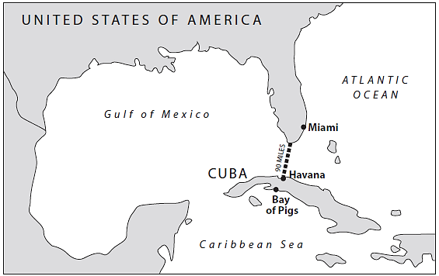
It is important to recognize how deeply Americans feared the Soviet Union. Although the two countries had fought together to defeat Nazi Germany just 15 years before, many people in the U.S. believed that the U.S.S.R wanted to take over the world and force everyone to embrace communism. By 1960, both the Soviet Union and the United States possessed thousands of nuclear missiles that were so powerful that a full-scale nuclear war between the two countries could have destroyed life on this planet. When Cuba moved toward communism and friendship with the U.S.S.R, Americans were intensely concerned.
The U.S. government decided Castro had to go. The Americans wanted to get rid of Castro and replace him with a Cuban leader who would be friendly with the United States and to American companies (as Batista had been). After all, Americans said, Cuba was “right next door” to the United States.
- In your opinion, did the U.S. have the right to try and change the government in Cuba by force? Why or why not?

In order to get rid of Castro, the United States began to give money, weapons and military training to a group of unhappy, anti-Castro Cuban exiles who were preparing for an invasion of Cuba. These exiles wanted to depose and rid Cuba of communism.
On April 17, 1061 the U.S. helped about 1,400 of these anti-Castro Cubans to invade Cuba at a place called Bahía de Cochinos, the Bay of Pigs. Although the United States denied actively taking part in the invasion, the world soon found out that this was not exactly true. Many nations, especially the Soviet Union and its allies, spoke out against American military support for the Bay of Pigs invasion. Soviet Chairman Khrushchev and President Kennedy exchanged a series of messages during the invasion.

Read the messages between Kennedy & Khrushchev and complete the chart & question below.
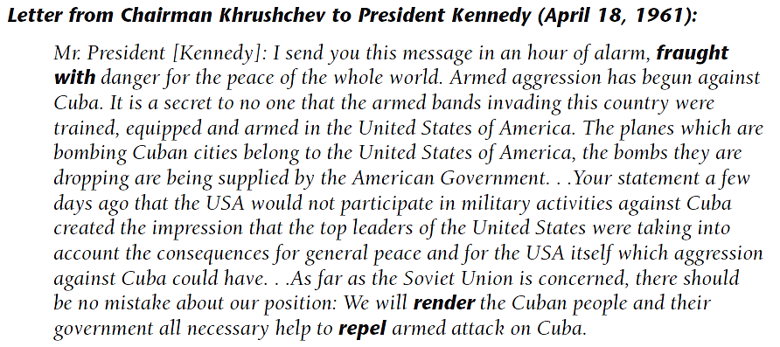
Fraught with: full of
Render: to give assistance or make available
Repel: to offer resistance to; to fight against
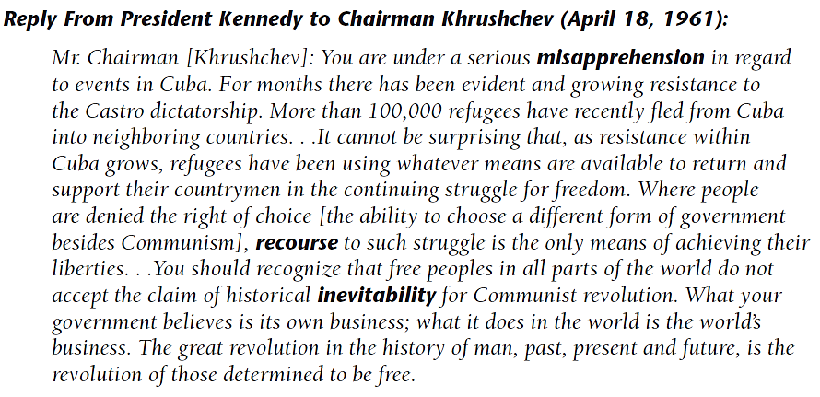
Misapprehend: to apprehend incorrectly; to misunderstand
Recourse: act of turning to for assistance
Inevitability: the quality of being unavoidable
 | President Kennedy | Chairman Khrushchev
Point of View, or perspective, regarding Fidel Castro and the Communist Revolution in Cuba
Objective (what each leader wanted to achieve in Cuba)
How might Kennedy and Khrushchev’s different objectives help explain how both men could look at the same historical event (the Bay of Pigs invasion) and yet come to such opposite conclusions?

The American government expected the people of Cuba to rise up in support of the invasion and help the invaders to overthrow Castro’s communist government. The Americans were disappointed. There was not popular uprising in Cuba against Castro, and the communist government easily defeated the invasion. President Kennedy was angry and humiliated.
Cuban Missile Crisis
Although he had defeated the Cuban exile’s invasion at the Bay of Pigs, Castro was afraid the United States still wanted to invade Cuba in order to get rid of him, change the government, and destroy Cuba’s Communist Revolution. So he asked his friend, Soviet Chairman, Khrushchev, for more help. He got it Khrushchev secretly began sending nuclear missiles to Cuba. Weapons of mass annihilation were now only 90 miles away from the United States. It is likely Khrushchev and Castro believes that these deadly missiles would convince the Unites States to leave Cuba alone. They were wrong.
The Unites States, using special spy planes equipped with powerful cameras, discovered that missile sites were being built and also came to the conclusion that Soviet ships were sailing from Russia to Cuba with offensive missiles (they did not know that some of these missiles had already reached Cuba).President Kennedy and his advisers were horrified by these discoveries. They felt that they had to respond to this situation. They problem was: “how?” What should they do about the possibility of nuclear missiles pointing at them from only 90 miles away?
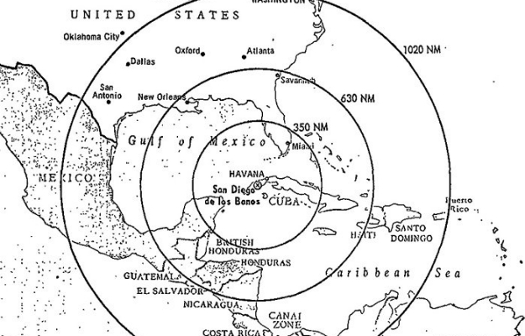
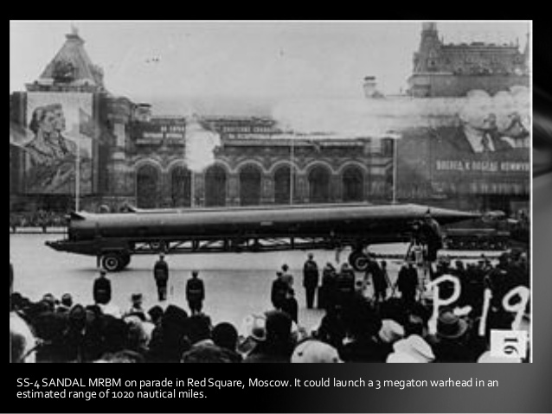

Range of missiles

The SS-4 SANDAL MRBM on parade in Red Square, Moscow. It could launch a three-megaton warhead to an estimated range of 1,020 nautical miles

- Can you tell what is pictured in the photo above? Why might pictures such as these have deeply disturbed Americans?

- What do you think this map shows?

- How might a mam like this have influences how President Kennedy responded to the growing “missile crisis”?

- What would you have advised President Kennedy to do? Why?

Some of Kennedy’s advisors recommended going to the United Nations and asking got its help. Other advisers, especially leaders in the American military like General Curtis LeMay (under whose command the United States had dropped nuclear weapons on Japan at then of WWII), told Kennedy that the United States must invade Cuba immediately in order to destroy the nuclear missile sites and defeat the Castro government. LeMay argued, essentially, that the Unites States would have to invade Cuba sooner or later so they might as well do it now. Kennedy, however, resisted attacking Cuba right away.
Instead of attacking Cuba Kennedy made this famous speech on October 22, 1962:
I have directed that the following initial steps be taken immediately: To halt this offensive [military] buildup, a strict quarantine on all offensive military equipment under shipment to Cuba is being initiates. All ships of any kind bound for Cuba from whatever nation or port will, if found to contain cargos of offensive weapons, be turned back…Should these offensive military preparations continue, this increasing the threat to the hemisphere, further actions will be justified. I have directed the Armed Forces to prepare for any eventualities…It shall be the policy of this nation to regard any nuclear missile launched from Cuba against any nation in the Western Hemisphere as an attack by the Soviet Union on the United States, requiring a full retaliatory response upon the Soviet Union…I call upon Chairman Khrushchev to halt and eliminate this clandestine, reckless, and proactive threat to world peace and to stable relations between our two nations. I call upon him further to abandon this course of world domination, and to join in an historic effort to end the perilous arms race and to transform the history of man.
- How does Kennedy characterize the actions of the Soviet Union?

- In your opinion, why did Kennedy not invade Cuba immediately to destroy the missiles? After all, Cuba is not a very big country.

- What did Kennedy mean when he said he was beginning a strict quarantine, or blockade, of Cuba with the American Navy?

- Why did he do this? What was the point of the “quarantine”?

The United States declare that it would not allow any Soviet ships carrying missiles or military equipment to pass through its blockade and reach Cuba. In response, the Soviets proclaimed that such a blockade was illegal and that they would continue sending supplies to their friends in Cuba. No one knew what would happen next.
How would the Americans react if the Soviet ships did not stop at the blockade line? What if the Soviet ships refused to turn around and go back to the U.S.S.R? What would the Soviets do if the Americans tried to stop the ships by force? Would America, as Castro feared, invade Cuba to destroy the missile sites and his revolution? The Soviet ships kept traveling, coming closer and closer to the American blockade. They whole word wondered: was there going to be a war between the world’s two most powerful nations?
The historian Author Schlesinger, who at the time was an aide to President Kennedy later said: This was not only the most dangerous moment of the Cold War. It was the most dangerous in human history.
- What to Schlesinger mean when he said this was “the most dangerous time in human history”? Why was this moment so incredibly dangerous?

As the Soviet ships reached the American quarantine line on October 24th, the stopped. The world held its breath. And then, most of the ships slowly turned around and began heading back to Russia.
As American Secretary of State Dean Rusk said. Were eyeball to eyeball, and I think the other fellow just blinked.
- What do you think Rusk meant by this statement?

Although one Soviet ship continued through the quarantine line, the Americans let it continue after searching it and determined that it carried no offensive weaponry. Still, the crisis continued and remained unresolved until after October 28th, when Kennedy and Khrushchev worked out a deal to resolve the crisis peacefully. How were the United States and the Soviet Union able to avoid a nuclear holocaust?

Resolving the Crisis
Here is the message that Chairman Khrushchev sent to President Kennedy on October 28, 1962:
In order to eliminate as rapidly as possible the conflict which endangers the cause of peace… the Soviet Government has given new order to dismantle the arms which you described as offensive, and to crate [box them up] and return them to the Soviet Union.
…Mr. President, I should like to repeat what I have already written to you in my earlier messages [which were sent on October 26th and 27th]- that the Soviet government has given economic assistance to the Republic of Cuba, as well as arms, because Cuba and the Cuban people were constantly under the continuous threat of an invasion of Cuba [by the United States]…The threat of invasion of Cuba and all other schemes for creating tension over Cuba are designed to strike the Cuban people with a sense of insecurity, intimidate them, and prevent them from peacefully building their new life… I regard with respect and trust the statement you made in you message of October 27, 1932, that there would be no attack no invasion of Cuba…[therefore] the motives which induced us to render assistance of such a kind to Cuba disappear.
- Summarize Khrushchev’s message.

- In Khrushchev’s message, he implies that the United States and the Soviet Union came to a compromise on order to resolve the crisis and avoid nuclear war over Cuba. What did President Kennedy do or say that convinced the Soviets to turn their ships around and, more importantly, to take apart their missiles in Cuba and send them back to the Soviet Union?

A form of government (this term is generally understood to have negative connotations f repression and authoritarian rule)
To convert from private to governmental ownership and control
One who lives away from one’s native country, whether because of expulsion or voluntary absence.
To remove from office or power

