“The Hangman” by Maurice Ogden

Into our town the Hangman came,
Smelling of gold and blood and flame,
And he paced our bricks with a different air
And built his frame on the courthouse square.
The scaffold stood by the courthouse side,
Only as wide as the door was wide;
A frame as tall, or little more,
Than capping sill of the courthouse door.

And we wondered, whenever we had the time,
Who the criminal,what the crime
The Hangman judged with the yellow twist,
Of knotted hemp in his busy fist.

And innocent though we were, with dread
We passed those eyes of buckshot lead;
Till one cried: “Hangman, who is he,
For whom you raise the gallows-tree?”

Then a twinkle grewin the buckshot eye,
And he gave us a riddle instead of reply:
“He who served me the best,” said he,
“Shall earn the rope on the gallows-tree.”

And he stepped down, and laid his hands
On a man who came from another land—
And we breathed again, for another’s grief
At the Hangman’s hand was our relief.

And the gallows-frame on the courthouse lawn
By tomorrow’s sun would be struck and gone.
So we gave him way, and no one spoke,
Out of respect for his Hangman’s cloak.

The next day’s sun looked mildly down
On roof and street in our quiet town
And, stark and black in the morning air,
The gallows-tree on the courthouse square.

And the Hangman stood at his usual stand
With the yellow hemp in his busy hand;
With his buckshot eye and jaw like a pike
And his air so knowing and businesslike.

And we cried: “Hangman, have you not done,
Yesterday, with the alien one?”
Then we felt silent, and stood amazed:
“Oh, not for him was the gallows raised…”

He laughed a laugh as he looked at us:
“Did you think I’d gone to all this fuss
To hang one man? That’s a thing I do
To stretch the rope when the rope is new.”

Above our silence a voice cried “Shame!”
And into our midst the Hangman came
To that man’s place. Do you hold,” said he,
With him that was meat for the gallows-tree?”

And he laid his hand on the one’s arm,
And we shrank back in quick alarm,
And we gave him way, and no one spoke
Out of the fear of his Hangman’s cloak.

That night we saw with dread surprise
The Hangman’sscaffold had grown in size.
Fed by the blood beneath the chute,
The gallows-tree had taken root.

Now as wide, or little more,
Than the steps that led to the courthouse door,
As tall as the writing, or nearly as tall,
Halfway up on the courthouse wall.

The third he took—we had all heard tell—
Was a usurer and infidel,
And “What,” said the Hangman, “have you to do
With the gallows-bound, and he a Jew?”

And we cried out: “Is this one he
Who has served you well and faithfully?”
The Hangman smiled: “It’s a clever scheme
To try the strength of the gallows-beam.”

The fourth man’s dark, accusing song
Had scratched our comfort hard and long;
And “What concern,” he gave us back,
“Have you for … the doomed and black?”
The fifth. The sixth. And we cried again:
“Hangman, is this the man?”
“It’s a trick,” he said, that we Hangmen know
For easing the trap springs slow.”

And so we ceased, and asked no more
As the Hangman tallied his bloody score;
And sun by sun and night by night,
The gallows grew to monstrous height.

The wings of the scaffold opened wide
Till they covered the square from side to side:
And the monster cross-beam, looking down,
Cast its shadow across the town.

Then through the town the Hangman came
And called in the empty streets my name—
And I looked at the gallows soaring tall
And thought: “There is no one left at all

For hanging, and so he calls to me
To help pull down the gallows-tree.”
And I went out with right good hope
To the Hangman’s tree and the Hangman’s rope.

He smiled at me as I came down
To the courthouse square through the silent town,
And supple and stretched in his busy hand
Was the yellow twist of the hempen strand.

And he whistled his tune as he tried the snap
And it sprang down with a ready snap
And then a smile of awful command,
He laid his hand upon my hand.

“You tricked me, Hangman.” I shouted then,
“That your scaffold was built for other men,
And I’m no henchmen of yours,” I cried.
“You lied to me, Hangman, foully lied!”

Then a twinkle grew in the buckshot eye:
“Lied to you? Tricked you?” he said. “Not I.
For I answered straight and I told you true:
The scaffold was raised for none but you.

“For who has served more faithfully?
Than you with your coward’s hope?” said he.
“And where are the others that might have stood
Side by side in the common good?”

“Dead,” I whispered: and amiably
“Murdered,” the Hangman corrected me:
“First the alien, then the Jew…
I did no more than you let me do.”

Beneath the beam that blocked the sky,
None had stood so alone as I—
And the Hangman strapped me, and no voice there
Cried “Stay!” for me in the empty square.

Directions: Answer the following questions about the poem in COMPLETE SENTENCES.

- Write down your reaction to this poem.

- How is the message in this poem similar to the first poem?

- What poem made the biggest impression on you? Why?

- What is the meaning behind the riddle?

- According to this poem what is the problem with being a bystander?

- If you were to create a visual for this poem, what would you focus on? What would you want the view to notice most?

Bystander ____________________________________________________________________________________________________________

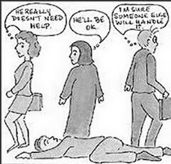
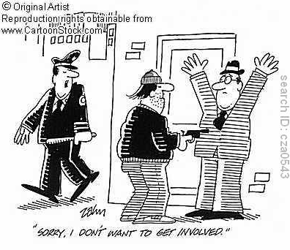
_________________________________________________________________________________________________________________________
- According to this poem what is the problem with being a bystander?
“First They Came” by Pastor Martin Niemoller

First they came for the Communists
And I did not speak out
Because I was not a Communist
Then they came for the Socialists
And I did not speak out
Because I was not a Socialist
Then they came for the trade unionists
And I did not speak out
Because I was not a trade unionist
Then they came for the Jews
And I did not speak out
Because I was not a Jew
Then they came for me
And there was no one left
To speak our for me

- What is wrong with this image?

- Are the bystanders innocent or guilty? Explain your answer.
- What is going on in this image?

- Who is the bystander?

- Who is the victim?

- Who is the offender?

- Is the bystander innocent or guilty? Explain your answer.

