13 Colonies Map: Label the 13 Colonies and the ocean to the right of the colonies
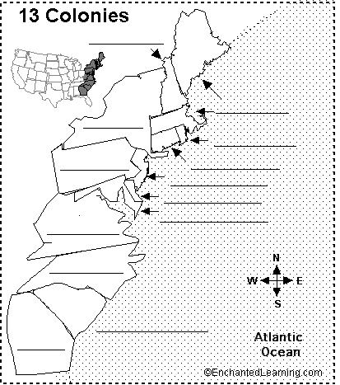
Colony Location: Next to each colony, write whether it is Southern Colony, a Middle Colony, or a New England Colony.

- New York
- Maryland
- Delaware
- Georgia
- Massachusetts
- North Carolina
- Pennsylvania
- New Jersey
- South Carolina
- Virginia
- New Hampshire
- Rhode Island
- Connecticut

Colonial Era Vocabulary: Write the complete definition of the following terms
- Proprietary Colony
- Charter Colony
- Royal Colony
- Pilgrim
- Puritan
- Quaker
- Persecution
- Triangular Trade
Plymouth v. Jamestown: After the following statements, write which settlement is represented.
- Named after King James I.
- This group government was based on the Mayflower Compact.
- Funded by the Virginia Company and went through the “starving time”.
- The people who lived in this settlement became known as the pilgrims.
- Motivation for colonization was religious freedom.
Which Colony? After the following statements, write which colony is represented.
- This Colony protected the English colonies from the Spanish in the south.
- Anne Hutchinson left Massachusetts to settle here.
- This colony is the location of Hartford.
- Maine was a part of this colony.
- This colony name came from the Dutch word for “Red Island”.
- This colony was named for the county of Hampshire in England.
- This colony was originally called “New Netherlands” It was founded by the Dutch, and renamed in 1664, when King Charles the II gave New Netherlands to his brother James “Duke of York”.
- This Colony was named for William Penn and was the 2nd largest colony.
- This was the smallest colony and was named for a Virginia governor “Lord De la Warr”.
- This colony was named for Queen Elizabeth I.
- This Catholic Colony was named for Queen Henrietta Maria of England.
- This colony was later split into two pieces.
- This was a colony for debtors.
- Thomas Hooker led a group of unhappy puritans here in 1636.
- This colony was named for the island of Jersey in the British Channel.
Culpepper’s Rebellion: Identify the following men.
- John Jenkins
- Thomas Eastchurch
- Thomas Miller
- George Durant
- John Culpepper
- Seth Sothel
French and Indian War:
- Who was involved?
- What was the impact of the war?

