Imperialism & World War I - Guided Notes
The Impact of the First World War
- 1914: World War I started, mainly involving Great Britain, France, Germany, and Austria.
- The United States took an active role in World War I.
- North Carolina affected the presence of the U.S. in the war in terms of politics and economics.
MANIA Sets In

- M__________________________: European powers began to develop __________________________in order to protect __________________________.
- A__________________________: European powers made a series of alliances for ____________________________.
- N__________________________: Europeans developed __________________________in their own countries/nationalities
- I__________________________: European powers fanned out across the globe in a race to control the most ____________________________________________________.
- A__________________________: Franz Ferdinand of __________________________ was assassinated in Bosnia by a __________________________.
Militarism- 1910 – 1914 Increase in Defense___________________________________
Alliances

Triple Entente
- __________________________
- France
- __________________________
  - Serbia
__________________________
- Germany
- __________________________
- Italy

Nationalism
__________________________- unification of all people speaking German or a Germanic language
Pan-Slavism - ________________________________________________________________________________________________________
Imperialism – European powers _________________________ pre=existing civilizations throughout Africa and _________________________________________________________________________________________________________________________
Assassination (___________________________________)
- The heir to the Austro-Hungarian throne, __________________________________________________, was shot and killed by a member of the a secret political society
- The assassination let directly to WWI when Austria-Hungary __________________________________________
Cause & Effect

- Trench Warfare a type of combat in which ________________ fight from trenches facing each other.
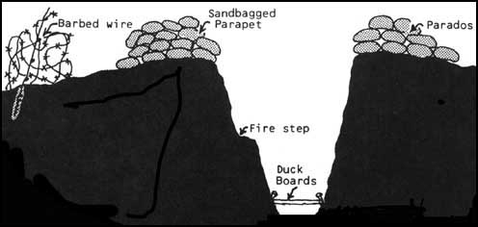

- For four years, the war dragged on, the front line ______________________________________. Only with the invention of the ____________________ did the strategy of “positional warfare” BEGIN TO FAIL.
The United States Remains Neutral
- Selling _______________________ to _____________________________
- The majority of American exports went to the _____________________________________________
- The ___________________________ began to target American __________________________ crossing the Atlantic
Lusitania -_______________________ luxury liner sunk by a _______________________________________ in the North Atlantic on May 7, 1915 (____________were Americans)
The Zimmerman Telegram was intercepted & decoded by ____________________________________ The telegram was a proposal from the __________________________Empire for ___________________ to join in an ____________________ with Germany in the event of the US entering WWI against Germany.
The US Declares War
With the ________________________________ into the war, the Germans made one last ditch effort to end the war before the arrival of US forces. This ___________________________, with France taking the majority of the hit, and the Germans folded knowing that the million plus troops on their way from America would be too much for them to handle.
The End of the War
Germany surrendered and agreed to sign a cease-fire agreement, or armistice, known as the ________________________________________________________
The Treaty punished the Germans by stripping them ____________________________________________________________
_________________________________________________________________________________________________________________________

Effects of the War on the US
- 19th Amendment
- 20th Amendment
- Isolationism
- World Power

Effects of the War on the world
- Treaty of Versailles
- European death & destruction
- Russian Revolution
- League of Nations
- Conflict in the Middle East

